PPG Signal Processing
1. Introduction
Photoplethysmography (PPG) is a non-invasive technique used to measure blood volume changes in the microvascular tissue. This report presents the processing of a synthetic PPG signal, including filtering, peak and valley detection, heart rate estimation, and abnormality identification.
2. Objectives
- Generate a synthetic PPG signal.
- Apply a Butterworth filter to remove noise.
- Detect peaks and valleys of the PPG signal.
- Compute heart rate from detected peaks.
- Identify abnormal heart rate values.
- Visualize each processing step through plots.
3. Methodology
3.1 PPG Signal Generation
A synthetic PPG signal is generated using a sinusoidal function with added noise. The signal is sampled at 100 Hz over a duration of 10 seconds.
3.2 Butterworth Filtering
A low-pass Butterworth filter of order 3 with a cutoff frequency of 2 Hz is applied to remove high-frequency noise and preserve the main signal components.
3.3 Peak and Valley Detection
The find_peaks function from the SciPy library is used to detect peaks (systolic points) and valleys (diastolic points) in the filtered PPG signal.
3.4 Heart Rate Calculation
Heart rate is estimated from the detected peaks using the time difference between consecutive peaks (RR intervals) and converting it to beats per minute (BPM).
3.5 Abnormality Detection
A heart rate below 50 BPM or above 100 BPM is considered abnormal. Detected abnormalities are displayed.
Code:
import numpy as np
import matplotlib.pyplot as plt
from scipy.signal import butter, filtfilt, find_peaks

# Generate synthetic PPG signal
def generate_ppg_signal(fs=100, duration=10):
t = np.linspace(0, duration, fs * duration)
ppg_signal = 1 + 0.5 * np.sin(2 * np.pi * 1.2 * t) + 0.2 * np.random.randn(len(t))
return t, ppg_signal

# Butterworth filter
def butterworth_filter(signal, fs=100, cutoff=2, order=3):
nyquist = 0.5 * fs
normal_cutoff = cutoff / nyquist
b, a = butter(order, normal_cutoff, btype='low', analog=False)
filtered_signal = filtfilt(b, a, signal)
return filtered_signal

# Detect peaks and valleys
def detect_peaks_and_valleys(signal, distance=50):
peaks, _ = find_peaks(signal, distance=distance)
valleys, _ = find_peaks(-signal, distance=distance)
return peaks, valleys

# Calculate heart rate
def calculate_heart_rate(peaks, fs=100):
rr_intervals = np.diff(peaks) / fs
heart_rates = 60 / rr_intervals
return heart_rates

# Identify abnormalities
def detect_abnormalities(heart_rates):
abnormalities = []
for i, hr in enumerate(heart_rates):
if hr < 50 or hr > 100:
abnormalities.append((i, hr))
return abnormalities

# Main execution
t, ppg_signal = generate_ppg_signal()
filtered_signal = butterworth_filter(ppg_signal)
peaks, valleys = detect_peaks_and_valleys(filtered_signal)
heart_rates = calculate_heart_rate(peaks)
abnormalities = detect_abnormalities(heart_rates)

# Plot raw signal
plt.figure(figsize=(10, 4))
plt.plot(t, ppg_signal, label='Raw PPG Signal', color='gray')
plt.title("Raw PPG Signal")
plt.xlabel("Time (s)")
plt.ylabel("Amplitude")
plt.legend()
plt.show()

# Plot filtered signal
plt.figure(figsize=(10, 4))
plt.plot(t, filtered_signal, label='Filtered PPG Signal', color='green')
plt.title("Filtered PPG Signal")
plt.xlabel("Time (s)")
plt.ylabel("Amplitude")
plt.legend()
plt.show()

# Plot raw and filtered signal together
plt.figure(figsize=(10, 4))
plt.plot(t, ppg_signal, label='Raw PPG Signal', alpha=0.7)
plt.plot(t, filtered_signal, label='Filtered PPG Signal', linewidth=2)
plt.legend()
plt.title("Raw vs Filtered PPG Signal")
plt.xlabel("Time (s)")
plt.ylabel("Amplitude")
plt.show()

# Plot PPG signal with peaks and valleys
plt.figure(figsize=(10, 4))
plt.plot(t, filtered_signal, label='Filtered PPG Signal')
plt.scatter(t[peaks], filtered_signal[peaks], color='red', label='Peaks', marker='o')
plt.scatter(t[valleys], filtered_signal[valleys], color='blue', label='Valleys', marker='x')
plt.legend()
plt.title("PPG Signal with Peaks and Valleys")
plt.xlabel("Time (s)")
plt.ylabel("Amplitude")
plt.show()

# Plot heart rate
plt.figure(figsize=(10, 4))
plt.plot(heart_rates, marker='o', linestyle='-', label='Heart Rate')
plt.axhline(y=100, color='r', linestyle='--', label='High HR Threshold')
plt.axhline(y=50, color='b', linestyle='--', label='Low HR Threshold')
plt.legend()
plt.title("Heart Rate Over Time")
plt.xlabel("Beat Number")
plt.ylabel("Heart Rate (BPM)")
plt.show()

# Print abnormalities
if abnormalities:
print("Detected Abnormal Heart Rates:")
for index, hr in abnormalities:
print(f"Beat {index + 1}: {hr:.2f} BPM")
else:
print("No abnormal heart rates detected.")
4. Results and Analysis
- Raw and Filtered Signal Comparison: The Butterworth filter effectively reduces noise while retaining the essential waveform characteristics.
- Peak and Valley Detection: The algorithm successfully identifies peaks and valleys in the signal.
- Heart Rate Estimation: The calculated heart rate is plotted to observe variations.
- Abnormality Detection: If any abnormal heart rate values are found, they are reported.
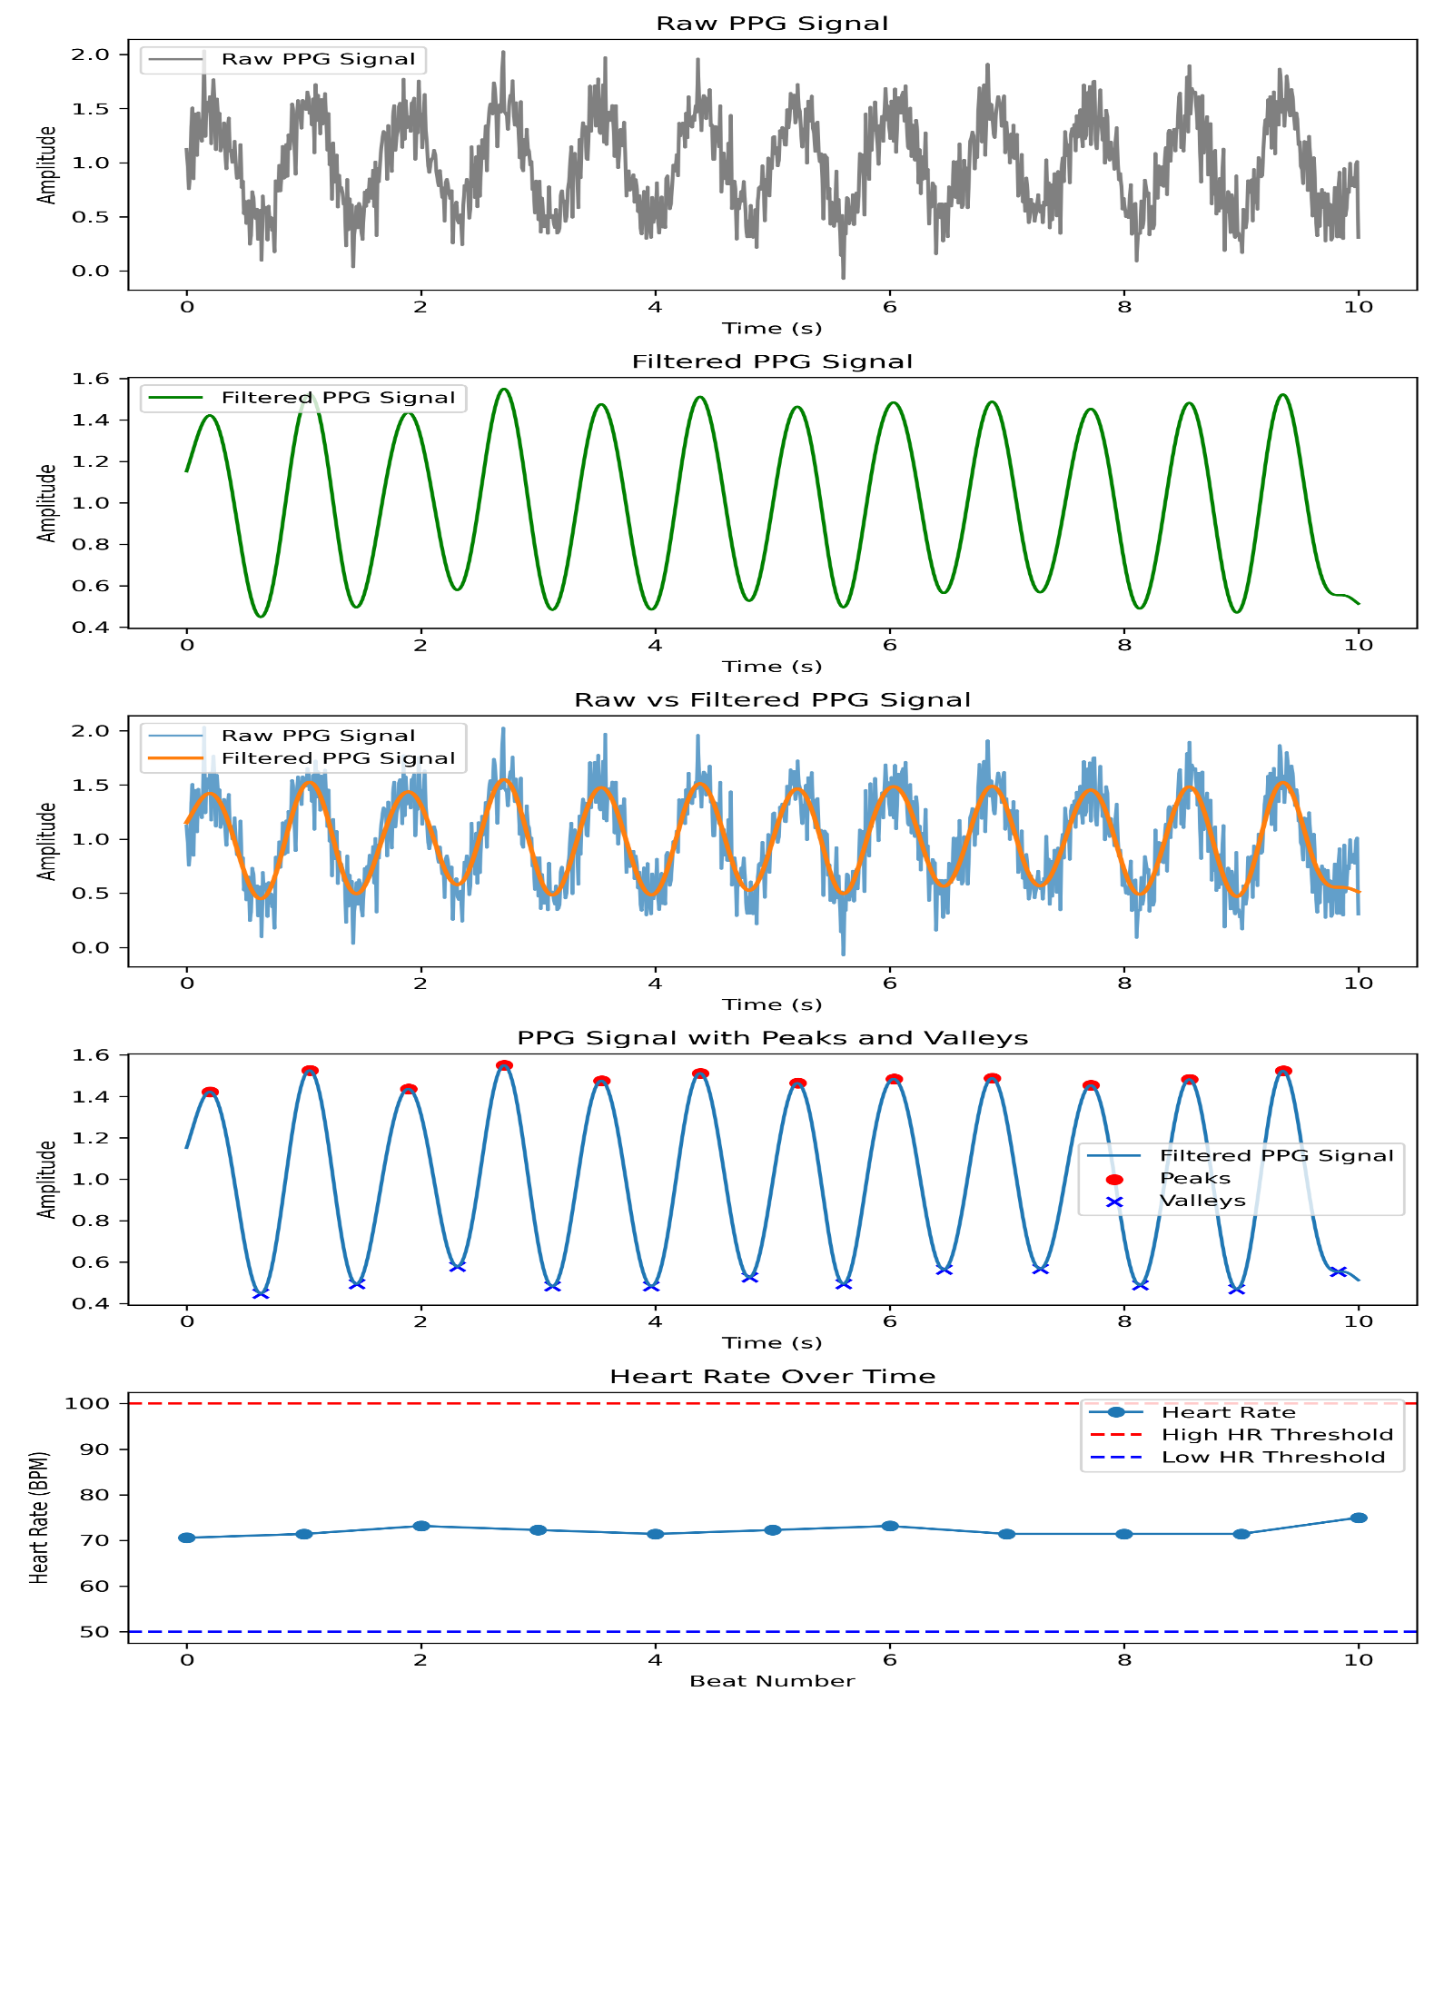
5. Conclusion
This lab successfully demonstrated PPG signal processing techniques, including noise filtering, peak and valley detection, heart rate estimation, and abnormality identification. The results highlight the importance of preprocessing for accurate physiological measurements.

